Contents
1.0 Project Details 2
2.0 Project overview 2
3.0 Document objective 2
4.0 user login 3
5.0 Clock in & Clock out 3
5.1. Clock In 4
5.2. Clock Out 5

Project Details
Name | Human Resource Information System
Description | Design, develop and implement the HRIS for Universal Harvester Dairy Farms Inc..
Sponsor | Human Resource Department – TLCI & UHDFI
Project Manager | Mr. Mc Austine Philip M. Redondo
Project Team Resources | Mr. Allan O. Roxas  Mr. Austine M. Redondo  Mr. Mark Topher Villaluz  Mr. Lendie Catubig | Mr. Jaycee Pasia  Mr. Jimmy F. Felix  Mr. Ken Juvic Marasigan

2.0 Project overview
- Improve and enhance the timekeeping process of BMC, currently manual.
- Free the company from a subscription-based application.
- Allows the company for greater control over sensitive employee data, enhancing security measures that align with the organization’s policies and compliance requirements.

3.0 Document objective
- Improve and enhance the timekeeping process of BMC, currently manual.
- Free the company from a subscription-based application.

4.0 User Login
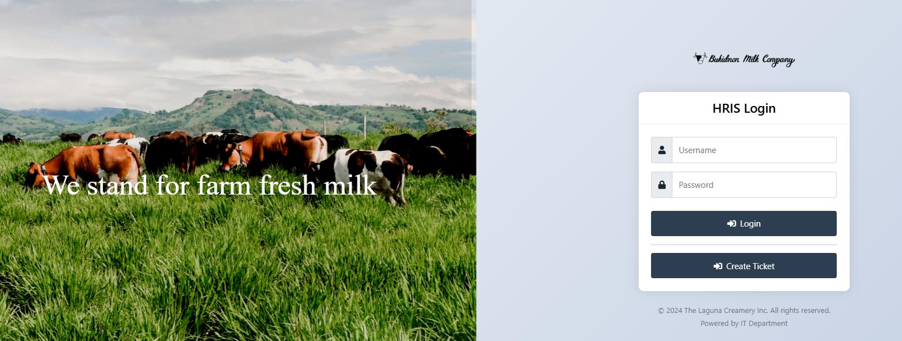
Image 1. Login Window
3
2
1

- Username: Input your correct username.
- Password: Input your correct password.
- Click login button to enter the system.
- Upon successful login, you will be redirected to the system dashboard.
Note: If you input wrong username or password, you will not be able to login.

5.0 Clock in & Clock out
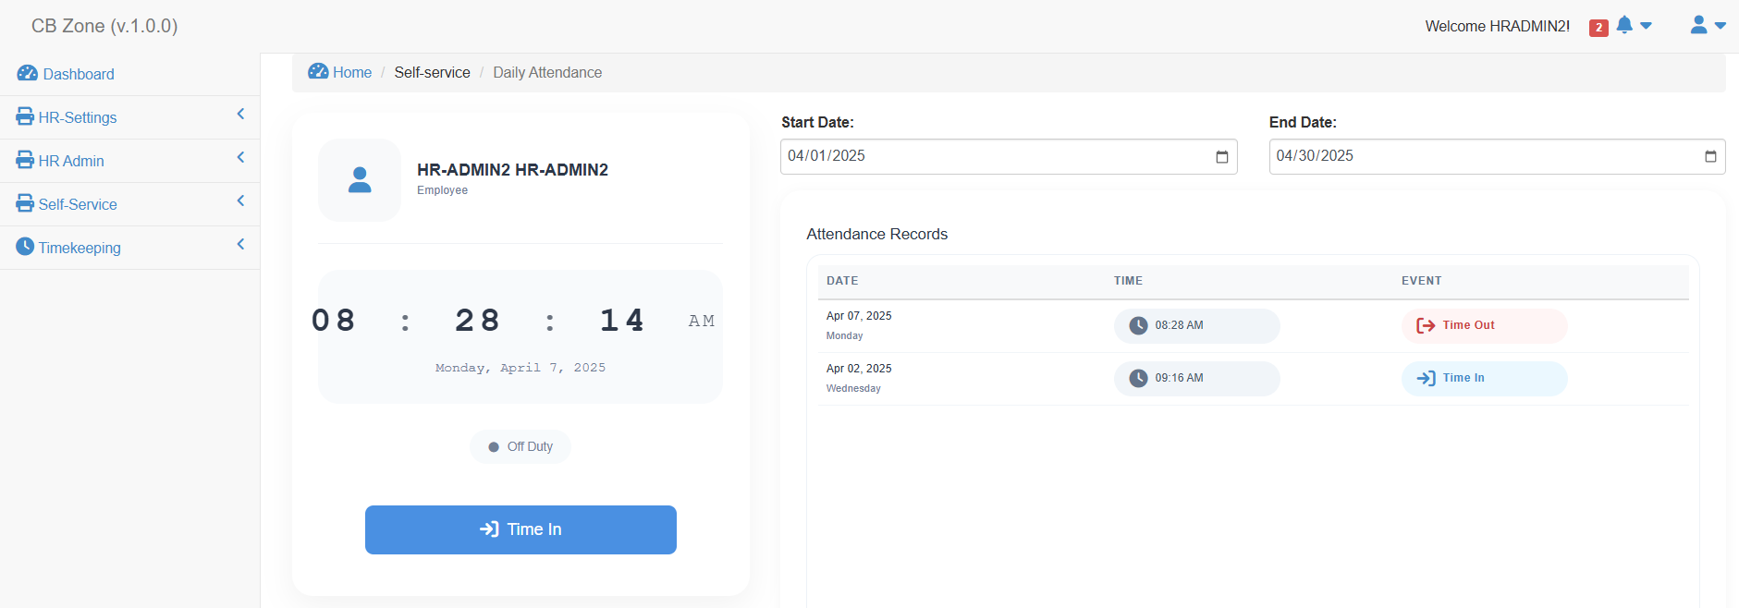
1
Image 2. Dashboard

5.1. Clock In
- Time In button is used to start your attendance every day.
- Once you click the time in button, a confirmation window will appear as shown on the image below.
Click yes to proceed.
Click no to cancel.
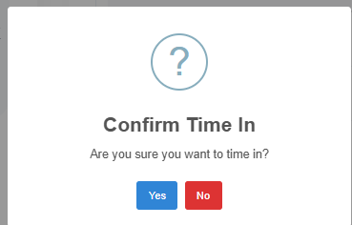

2

- A success window will appear if the clock in is successful. Then click ok button to proceed.
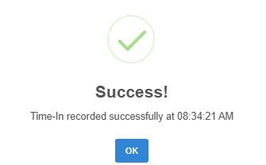

3

- The time in button will change to time out button after clock in.
- Your clock in will reflect on the attendance record table.
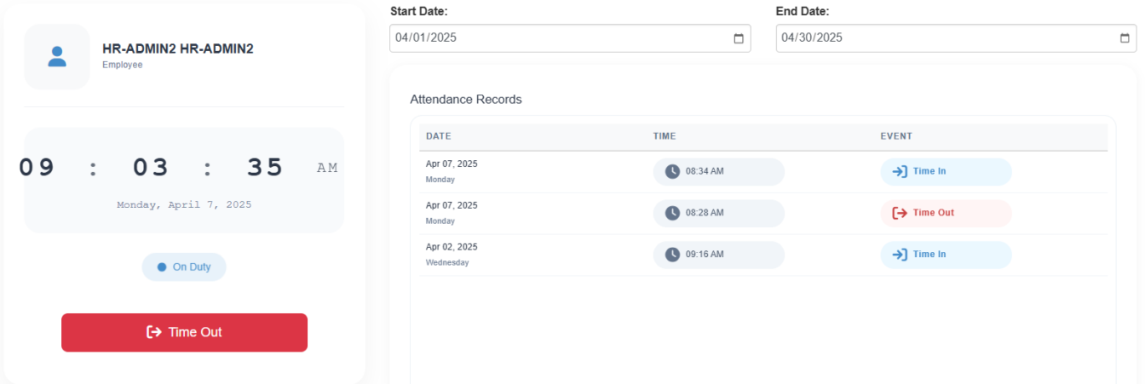
4
5

5.2. Clock Out
- Time out button is used to end your attendance every day.
1
- Once you click the time out button, a confirmation window will appear as shown on the image below.
Click yes to proceed.
Click no to cancel.
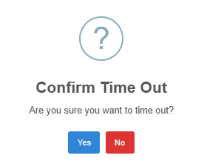

2

- A success window will appear if the clock out is successful. Then click ok button to proceed.
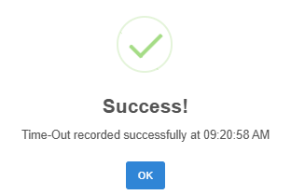

- The time out button will change to time in button after clock out.
- Your clock in will reflect on the attendance record table.
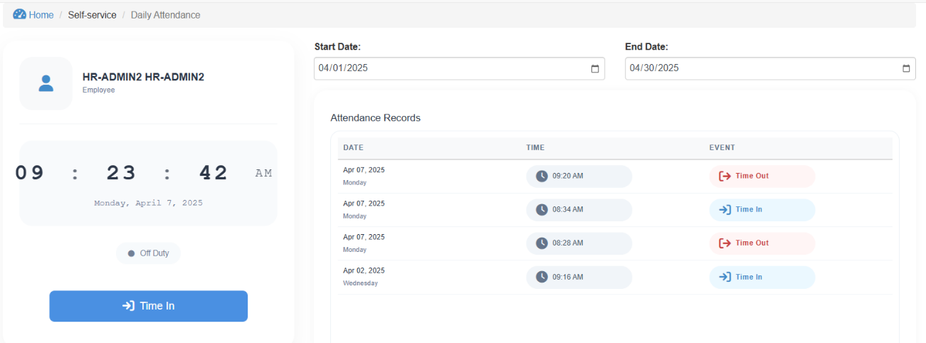

5

4

6.0 Self Service

6.1. Change Schedule
- Navigate the change schedule by clicking the Self-Service catalog in the navigation bar.
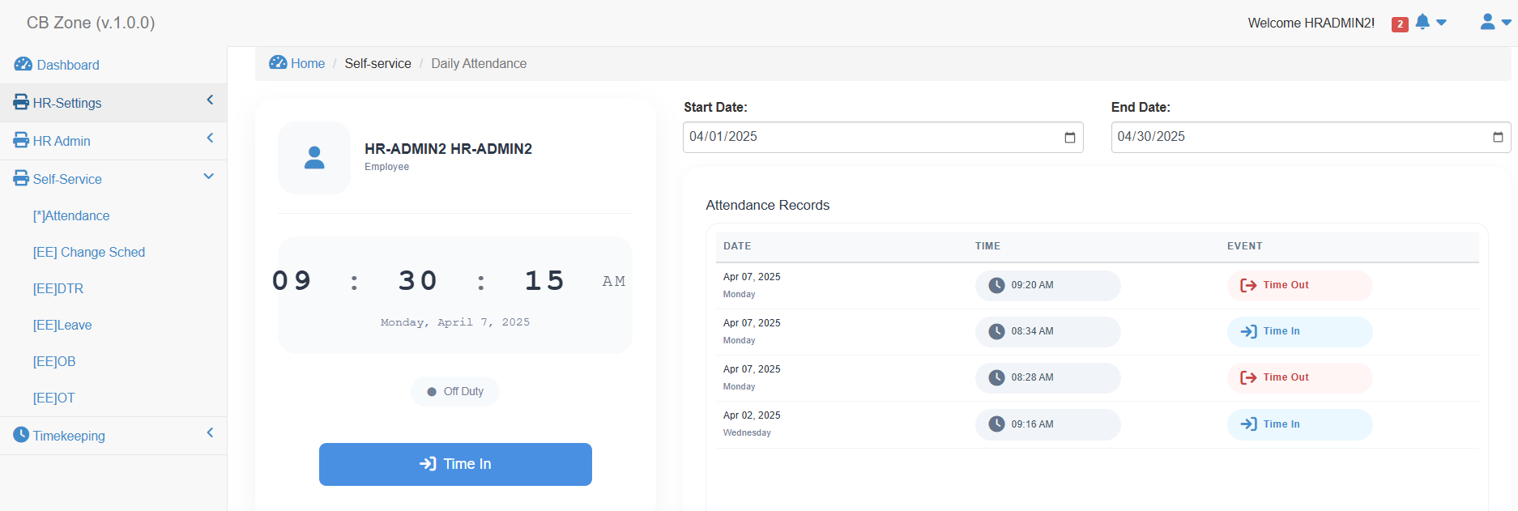
1

2

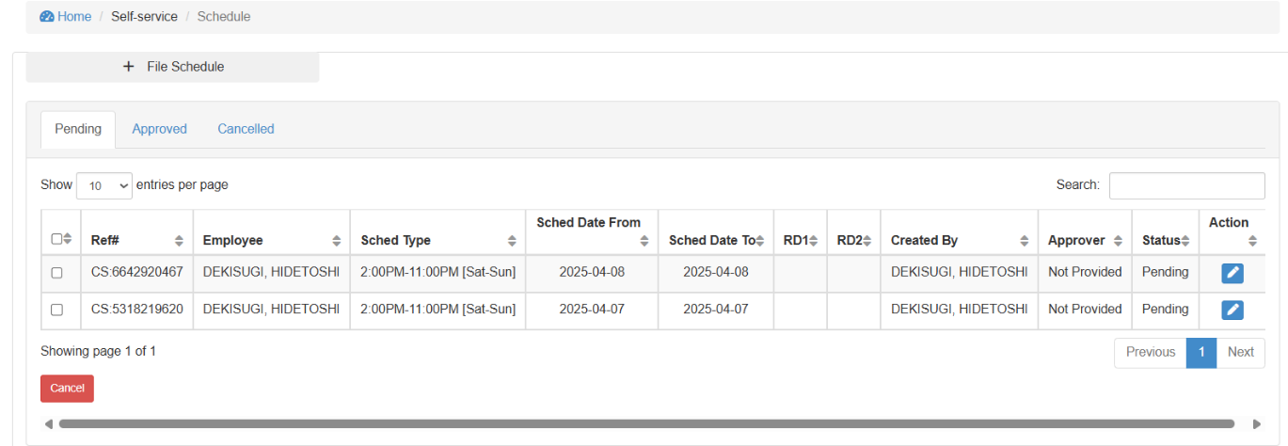
- Click [EE] Change Sched link to open Change Schedule window. The employee change schedule window will be displayed as shown on image 3.
3
Image 3. Employee Change Schedule.
- Click file schedule button to open the Change Schedule Form. The change schedule form is showed on the image 4.
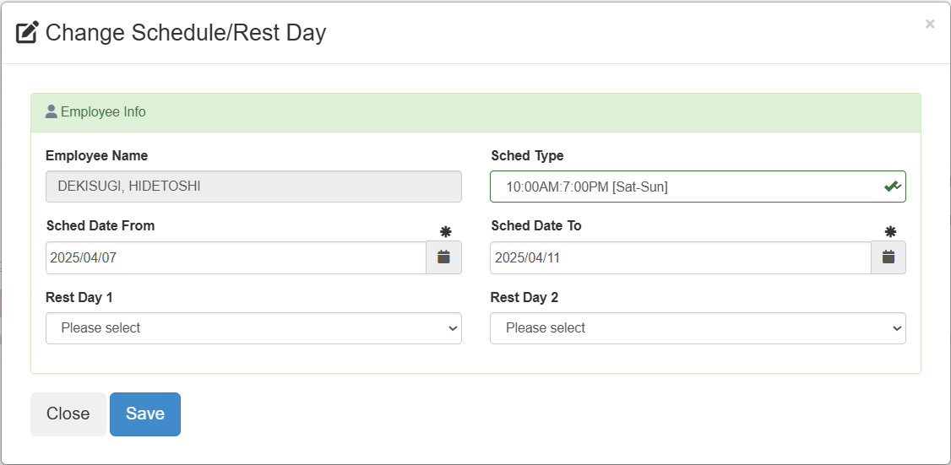

4

Image 4. Employee Change Schedule Form.
Table 1. Employee Change Schedule Form Fields.

Field | Description
Employee Name | Your name will display in this field.
Sched Type | Select the schedule type of your schedule. Schedule list is provided appendix A.)
Sched Date From | Select the start date of your selected schedule type.  Your selected schedule will start taking effect on the selected date.
Sched Date To | Select the end date of your selected schedule type.  Your selected schedule will end taking effect on the selected date.
Rest Day 1 | Select Rest Day 1 if you need to change your rest day 1  By default, each schedule type carries Rest Day 1 & Rest Day 2. Refer to appendix A.
Rest Day 2 | Select Rest Day 2 if you need to change your rest day 2.  By default, each schedule type carries Rest Day 1 & Rest Day 2. Refer to appendix A.

- Click save button to save your change schedule.
Success message will be displayed.
Note that you should not file for schedule that will overlap the other schedules.
Once created successfully, it will be sent to the assigned approver for their review and approval.
If the column approver contains “Not Provided”, it means the employee does not have approval setup.

6.2. Leave
- Navigate the leave by clicking Self-Service catalog in the navigation bar.
1

2

- Click [EE] Leave link to open leave window. The employee leave window will be displayed as shown on image 5.
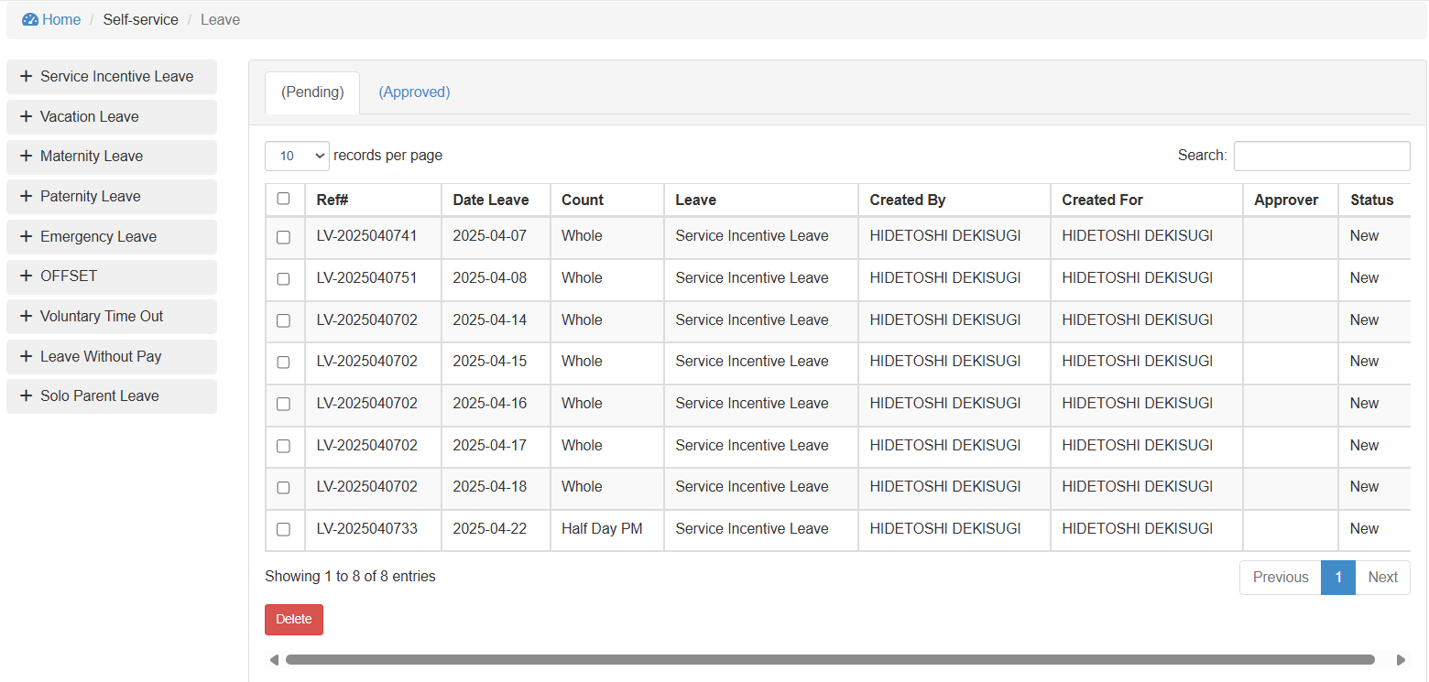
3
Image 5. Employee Leave.

- Click one button on the list of available leave. It will open a leave form as shown below.
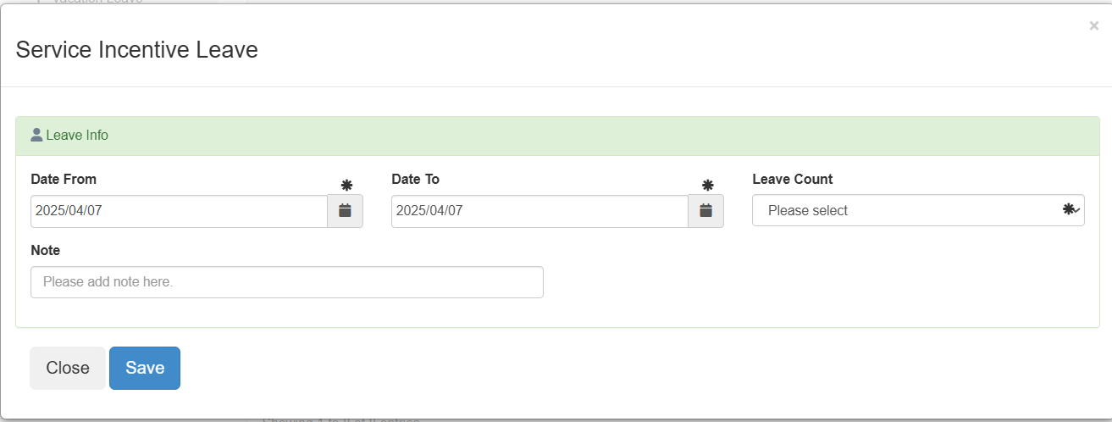

Table 2. Leave Type.

Leave | Description
Service Incentive Leave | This is the standard leave used by UHDFI that has leave credits.
Vacation Leave
Maternity Leave
Paternity Leave
Emergency Leave
OFFSET
Leave Without Pay
Solo Parent Leave | No leave credits, follow HR implementation.

- a
- sa

6.0 Self Service

